

Jenkins Installation

**Required Files**

- jenkins.war file to run Jenkins on local host (local machine)

Steps to follow:

1. Go to the link and download the war file

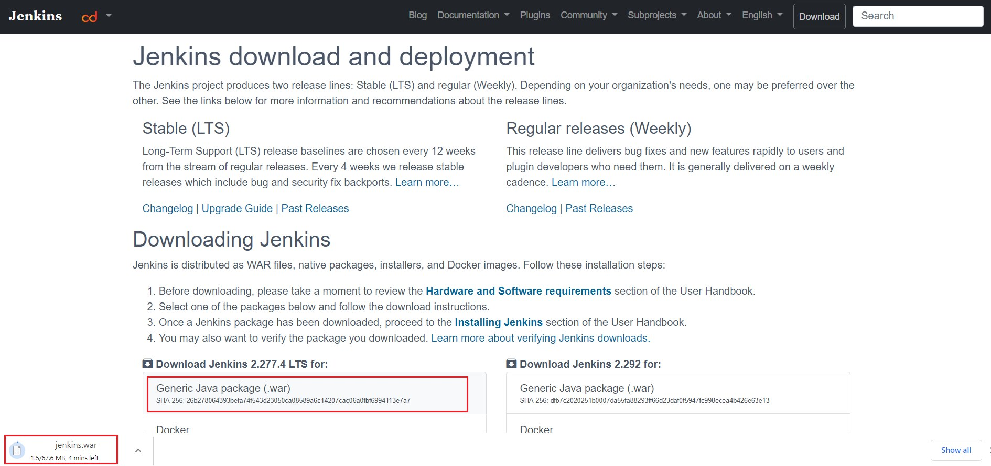

**Or** also can be downloaded directly by clicking the below link

<http://mirrors.jenkins.io/war-stable/latest/jenkins.war>

3. After downloading the war file, navigate to the downloaded folder and start command prompt (by typing cmd in the address bar)

Type: **java –jar jenkins.war**

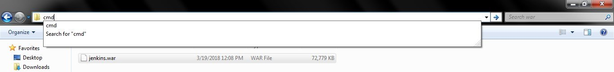

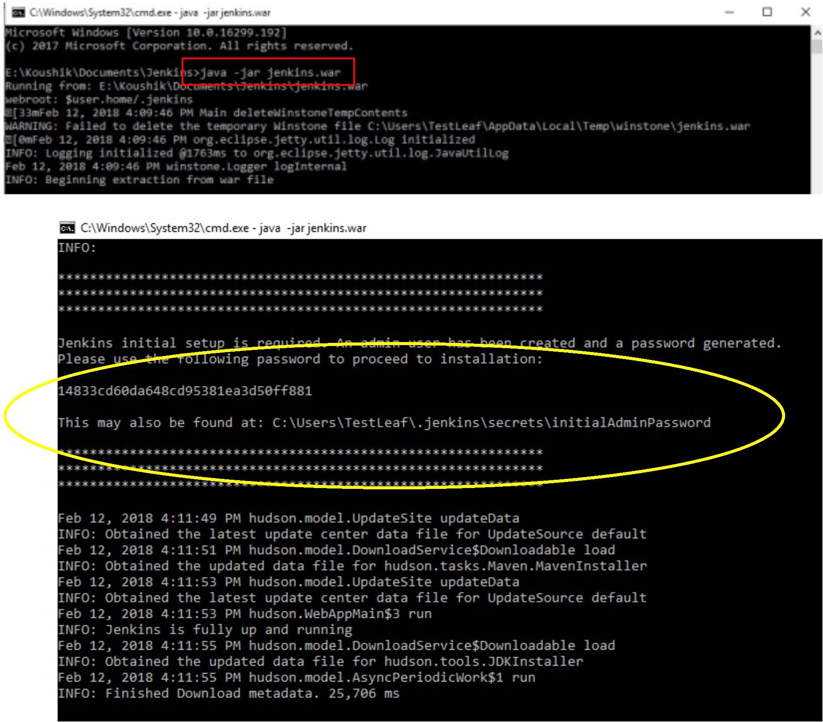

4. Open Chrome browser

5. Type the url - localhost:8080 and type the password shown in the console

(Copy & paste the password) – Highlighted in yellow color on the above snap

6. Click Continue

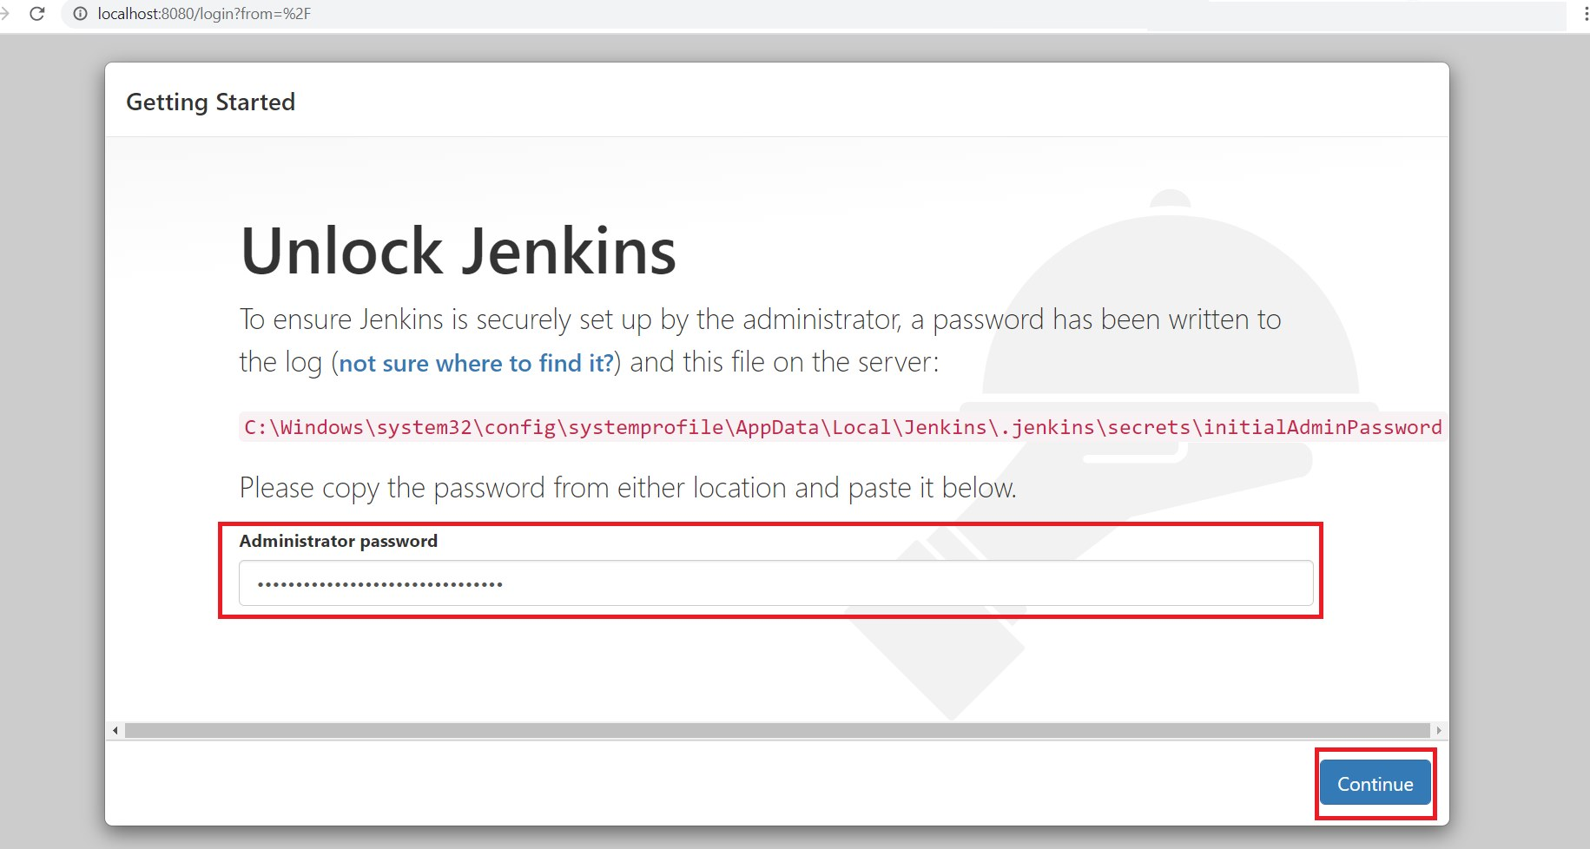

7. Click Select plugins to install

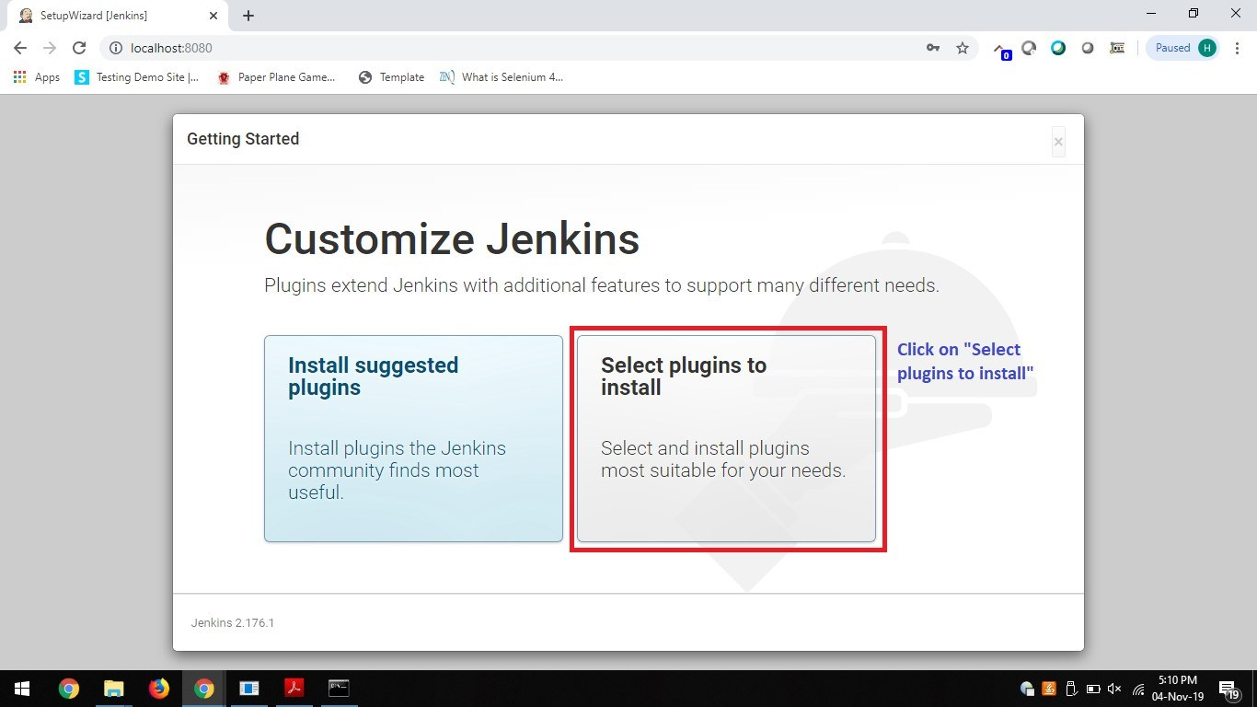

Installation of plugins will take some time, depending upon the internet connectivity speed

(If you are not able to see the page, check the index page for solution)Top of the Document

8. Click None

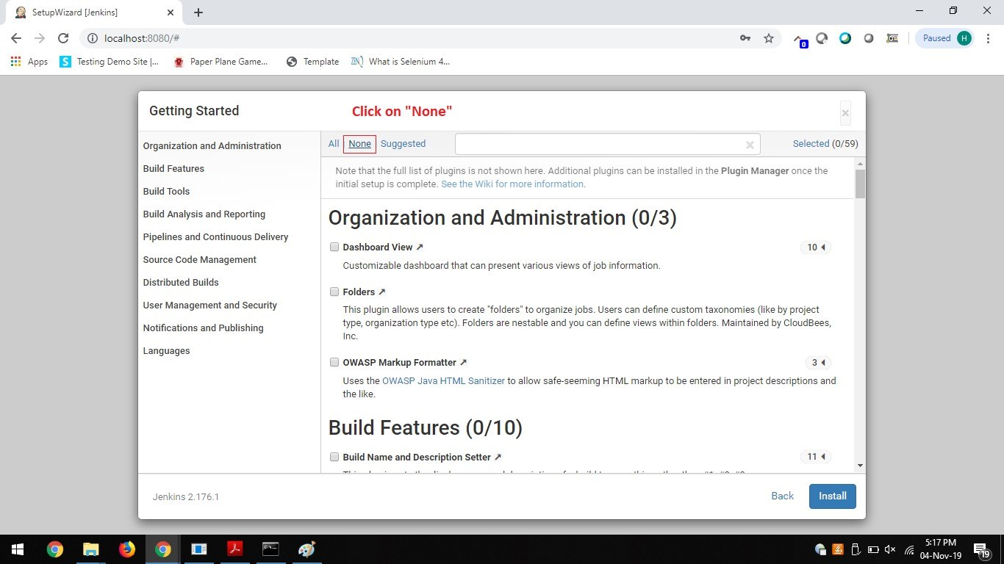

9. Install Git plugin

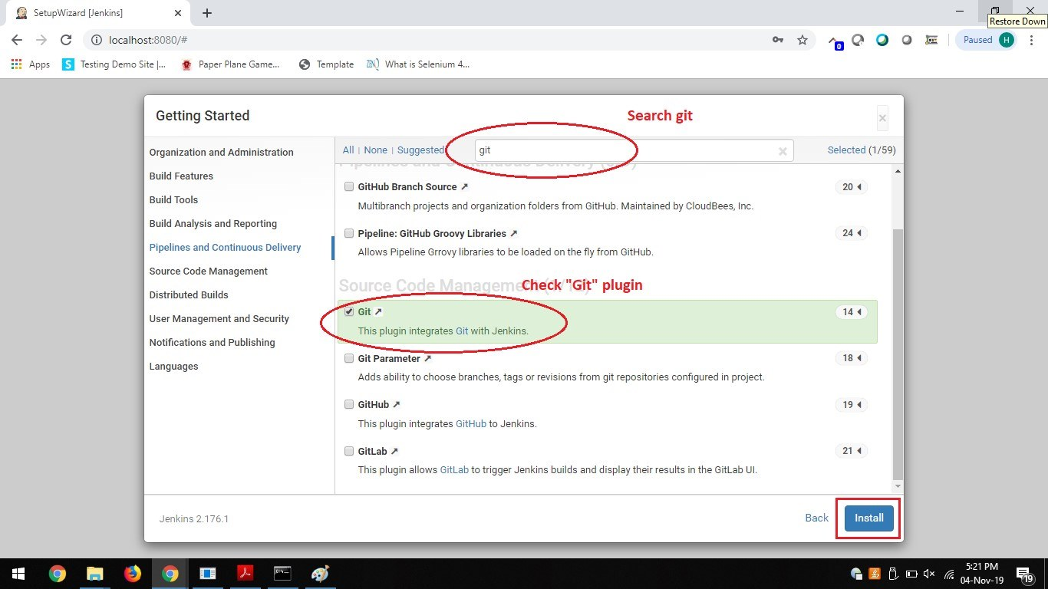

Once Git plugin is installed successfully,

10. Click Continue as admin

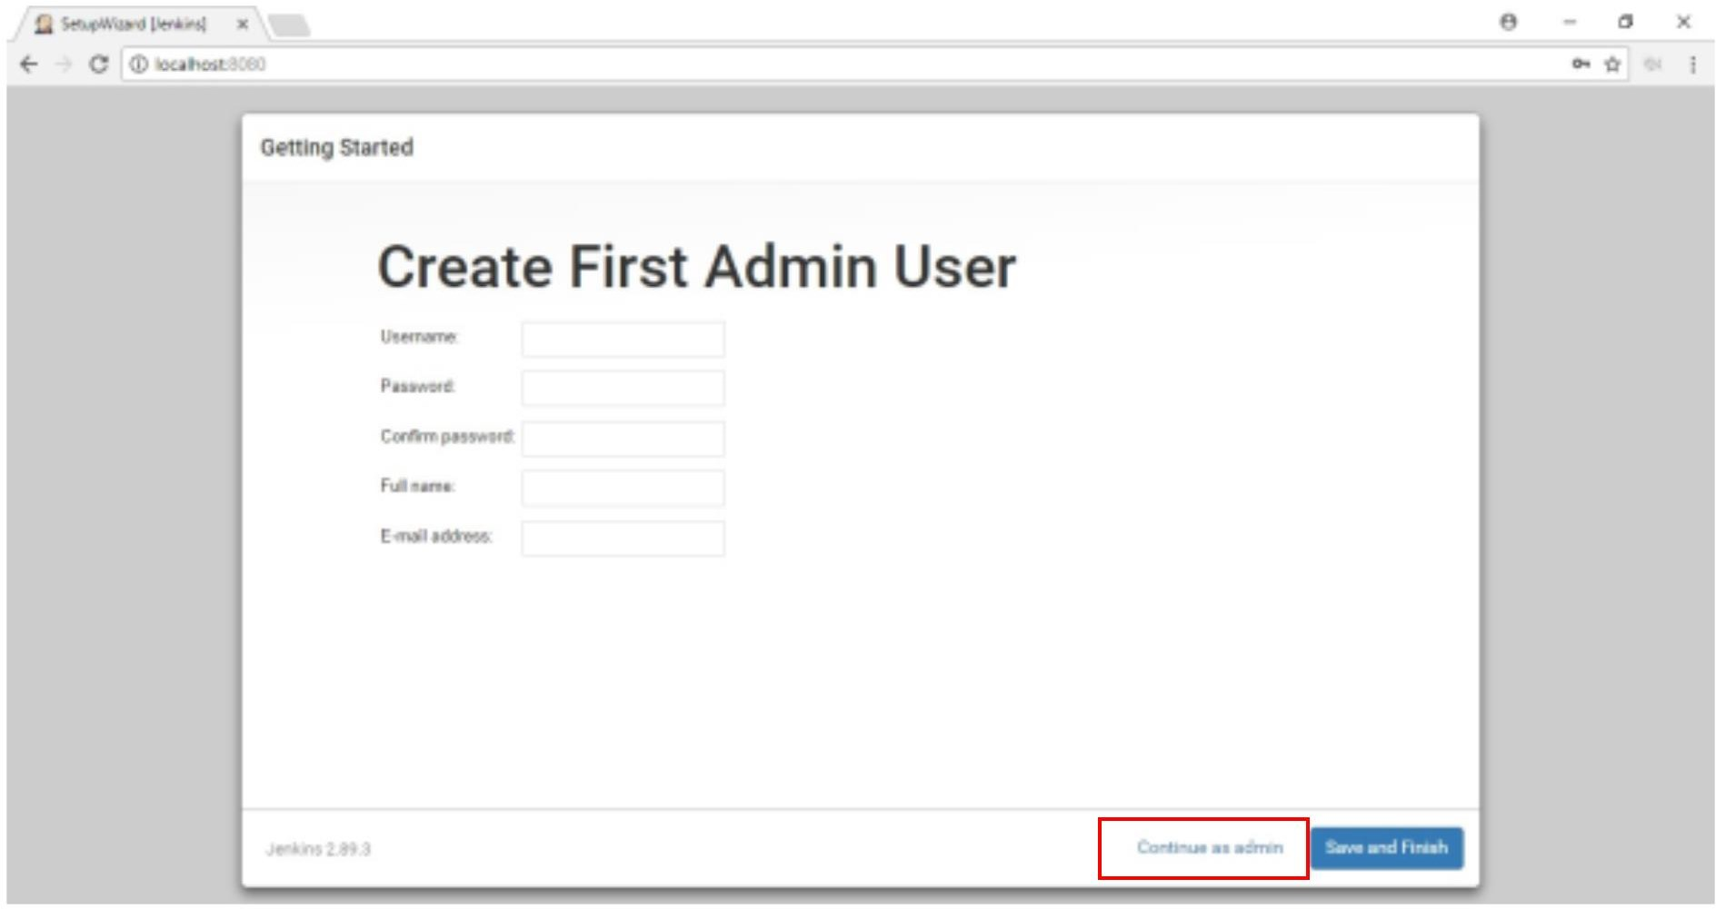

11. Click Save and Finish

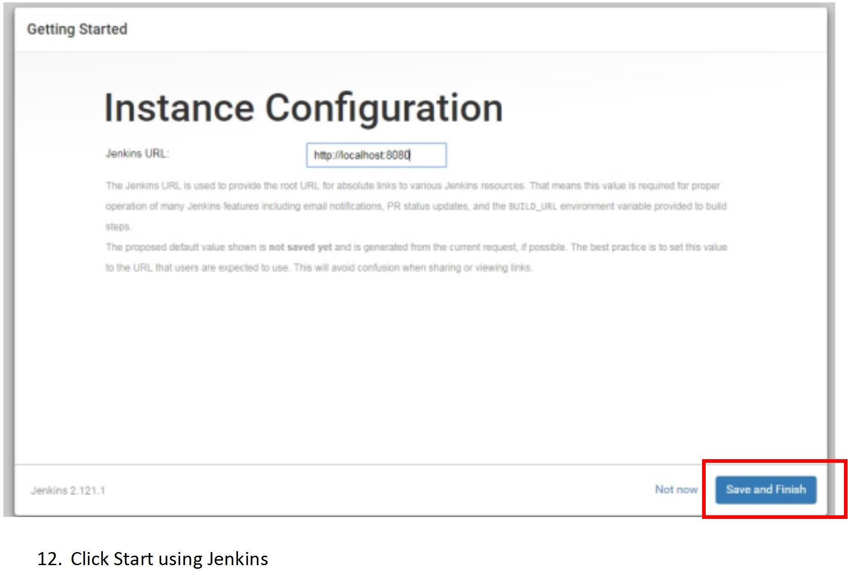

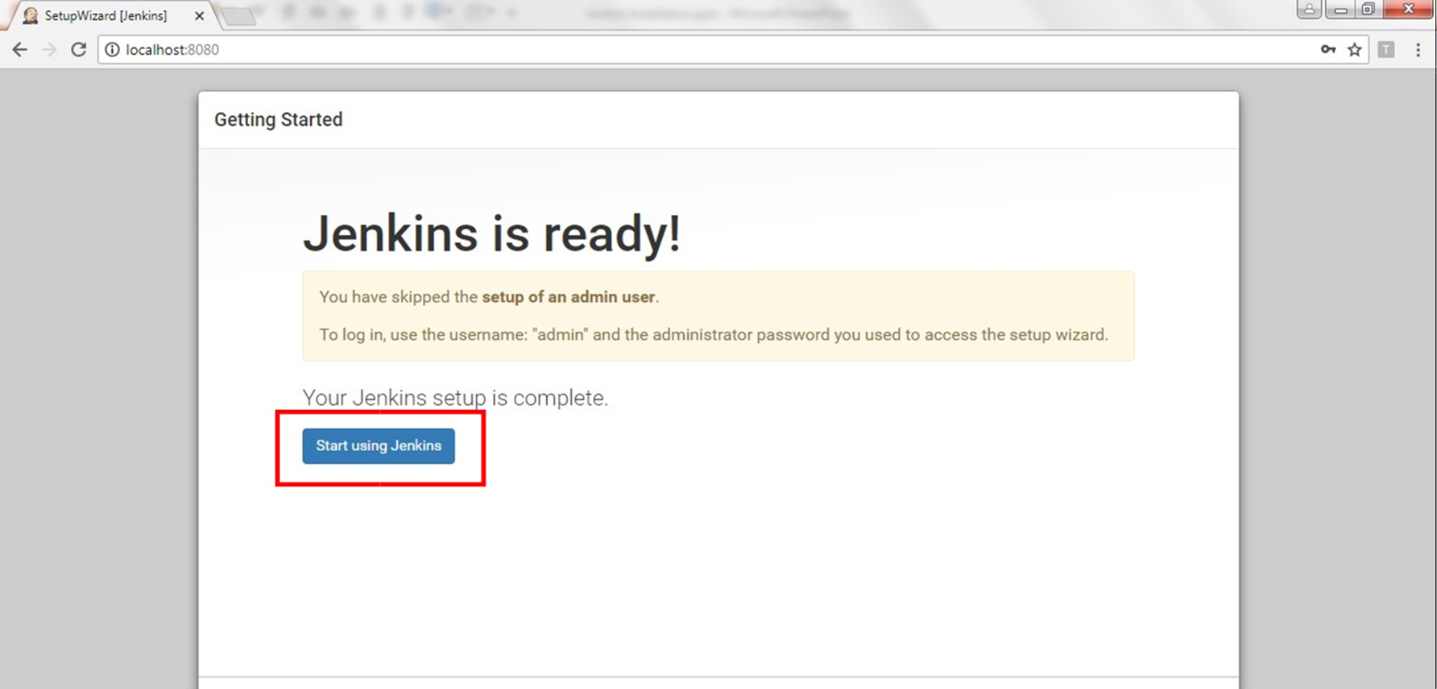

13. All Set with Jenkins Installation

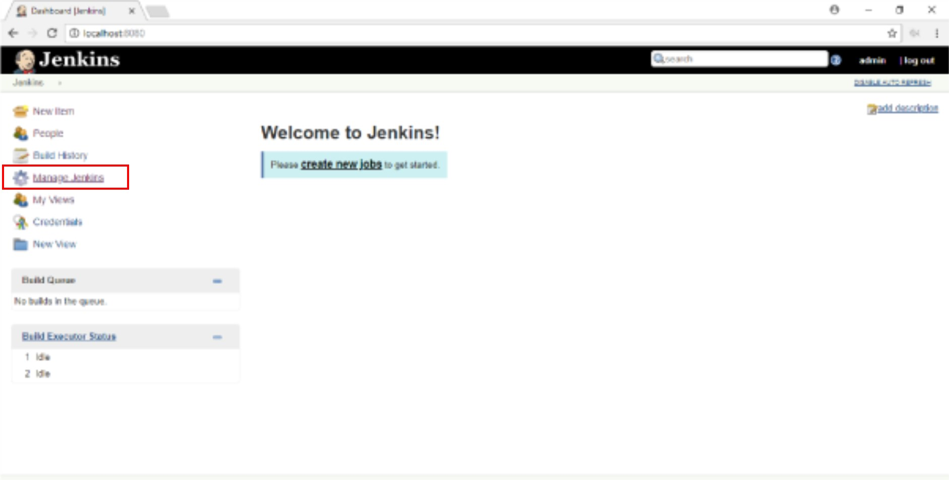

**Note:** If the command prompt is closed Jenkins will not run.

Complete the installation fully, if stops in between you will face issues

**Note: Username:** admin **Password:**

**It can be found in the location C:\Users\(user name)\.jenkins\secrets\initialAdminPassword -> Right click the file and open with notepad**

That’s all.

Congratulations Installation completed.

Thank you!

# 2. Common Issues



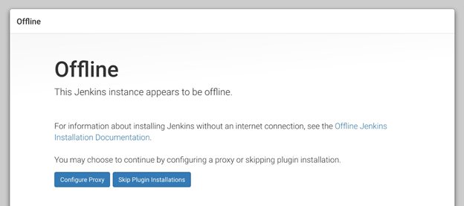

Solution:

1. Close Jenkins console (Close the cmd prompt)
2. Close Browser
3. Go to C drive -> Users -> your username -> .jenkins
4. In that folder right click on the file **hudson.model.UpdateCenter.xml** and open with notepad

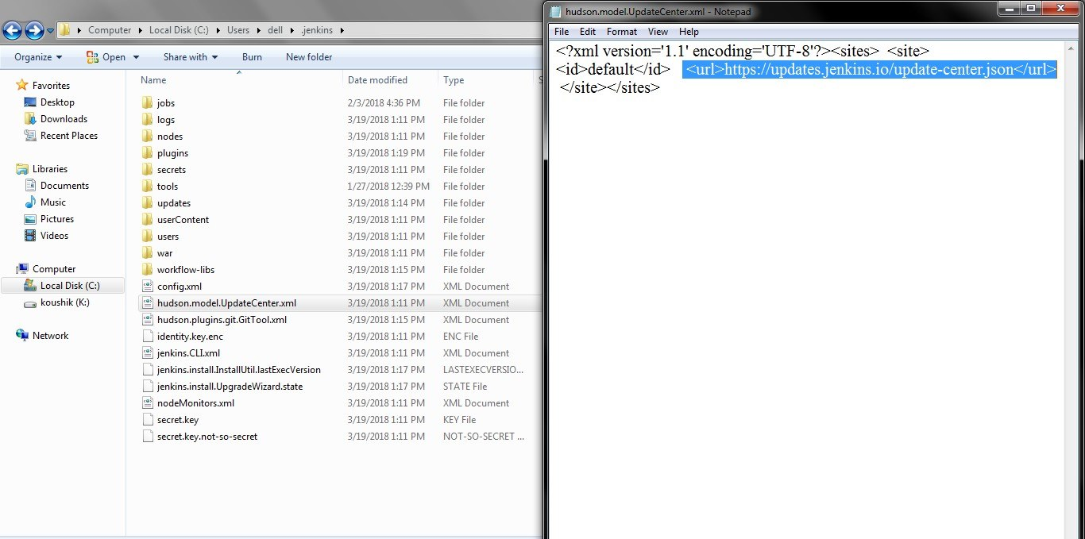

Edit the URL to

<url>[http://updates.jenkins.io/update-center.json</url>](http://updates.jenkins.io/update-center.json</url) (https to http)

**Save the file and close**. Start the installation again from **step 3**

# 3) Password



If you run Jenkins second time it won’t show password in the console.

To get the password, follow the instruction.

**Username:** admin **Password:**

**It can be found in the location C:\Users\(user name)\.jenkins\secrets\initialAdminPassword ->**

**Right click the file and open with notepad**